**HMM-Based Summarization of Web Content, YouTube Videos, and Document Files for Interactive Educational Platforms**

**Abstract :** The rise of Hidden Markov Models (HMM) in natural language processing (NLP) has provided a powerful method for automated text summarization. This paper proposes a comprehensive multi-modal educational platform that integrates three key summarization sources: web content, YouTube videos, and uploaded documents. Our platform leverages BeautifulSoup for web scraping, the YouTube API for extracting video transcripts, and custom file processing techniques to handle document files in .txt and .pdf formats. The core of the platform is an HMM trained to predict sentence importance, enabling it to generate concise summaries. Additionally, the platform supports text-to-speech (TTS) conversion using Google Text-to-Speech (gTTS), delivering summaries in audio format for enhanced accessibility. The platform’s performance is assessed using ROUGE metrics (ROUGE-1, ROUGE-2, ROUGE-L), demonstrating its ability to generate coherent, concise, and informative summaries across diverse content types. This multi-modal approach can reduce cognitive load and improve learning efficiency, making it highly relevant for educational platforms.

**Keywords** : Hidden Markov Model (HMM), Summarization, Web Scraping, YouTube API, Text-to-Speech, ROUGE Metrics, Educational Platforms.

**Introduction**

In today’s information-rich world, especially with the surge in online educational resources, there is a growing need for tools that help users quickly process and digest large volumes of content. Sifting through vast amounts of data, whether it's web articles, educational videos, or document files, can be time-consuming and mentally overwhelming. To address this challenge, this paper introduces a comprehensive multi-modal educational platform designed to summarize content from three major sources: web content, YouTube videos, and uploaded document files (.txt and .pdf).The platform aims to provide concise, meaningful summaries by leveraging advanced Natural Language Processing (NLP) techniques, particularly the Hidden Markov Model (HMM). Users can input URLs of web pages, links to YouTube videos, or upload documents, and the system will generate a summary of the key points from these sources. This is achieved through three main components: (1) a web scraping module using BeautifulSoup to gather text from web pages, (2) a YouTube video transcript extraction module that leverages the YouTube Transcript API, and (3) a document summarization module capable of processing .txt and .pdf files.

Each of these components feeds text data into an HMM-based summarization model that identifies the most important sentences based on sentence structure, word frequency, and sequence patterns. The platform enhances accessibility by incorporating Google Text-to-Speech (gTTS) technology, converting summarized text into audio for users who prefer listening.This feature is especially useful for auditory learners, individuals with visual impairments, or anyone who prefers audio content consumption. The integration of Text-to-Speech (TTS) transforms the platform into a versatile tool that accommodates a wider range of users. From a technical perspective, the HMM plays a crucial role in the summarization process, modeling sequences of sentences and determining their importance.HMMs are well-suited for this task due to their ability to capture observable and hidden states. Sentences in the input content are classified into summary or non-summary states based on model predictions derived from training on datasets of summaries. The model accounts for factors such as word frequency, sentence length, and the position of sentences in the text.Once the summarization process is complete, the platform outputs both a text summary and an audio version generated through gTTS. One of the key benefits of this platform is its multi-modal nature, allowing users to receive concise information from web articles, video transcripts, and uploaded documents in one place.

Moreover, the platform evaluates the quality of its summaries using established metrics such as ROUGE-1, ROUGE-2, and ROUGE-L. These metrics compare generated summaries with reference summaries to measure the overlap of unigrams, bigrams, and the longest common subsequence. High ROUGE scores indicate effective information capture from the original content.Another key feature is the platform’s focus on educational applications. By summarizing lengthy documents, articles, and videos, it can reduce cognitive load on users and save valuable time. Students can benefit from concise summaries of research papers, lecture videos, and textbook content, while teachers can quickly review instructional material and create condensed versions for classes.Additionally, the inclusion of text-to-speech (TTS) enhances accessibility for users with visual impairments or reading difficulties, ensuring educational content is accessible to a broader audience. The proposed system’s architecture is designed to be modular and scalable, allowing for future improvements and the addition of new content sources, such as social media summaries or online course content.

**2. Related Works:**

**2.1 Hidden Markov Models in Natural Language Processing:**

Hidden Markov Models (HMMs) have become fundamental tools in natural language processing (NLP) due to their ability to model sequential data effectively. They have been widely applied in various NLP tasks, including part-of-speech tagging and speech recognition. In part-of-speech tagging, HMMs predict the grammatical category of each word based on its context, effectively capturing dependencies between words. Similarly, in speech recognition, HMMs model the temporal dynamics of speech signals, facilitating accurate transcription of spoken language into text. These applications demonstrate the versatility of HMMs in understanding linguistic structures and their relevance to the broader field of NLP.

**2.2 Extractive Summarization Techniques:**

HMMs have shown particular effectiveness in extractive summarization tasks, which involve identifying the most salient sentences within a document. Unlike abstractive summarization, which generates new sentences, extractive summarization retains original wording and structure, focusing on selecting key sentences. HMMs accomplish this by analyzing observed word patterns and their frequencies, thus predicting which sentences are most crucial for conveying the text's core message. Previous studies have illustrated the utility of HMMs in summarizing academic papers, news articles, and corporate reports, affirming their capability to distill essential information from extensive documents.

**2.3 Distinction Between Extractive and Abstractive Summarization:**

Understanding the difference between extractive and abstractive summarization methods is vital in the context of this research. Extractive summarization selects and ranks existing sentences from the source text, preserving the original context. Conversely, abstractive summarization generates new sentences that paraphrase the source material, requiring a deeper comprehension of the text’s meaning. While both approaches have their benefits, extractive summarization is often preferred in practical applications due to its straightforward implementation and reliability in retaining essential content.

**2.4 Web Scraping Techniques:**

The rise of web scraping as a means to extract information from online sources has greatly enriched the field of summarization. Libraries such as BeautifulSoup have gained popularity among researchers and developers for their ability to parse HTML and XML documents easily. BeautifulSoup enables users to navigate the hierarchical structure of web pages, facilitating the extraction of specific elements, such as text, images, and links. This ability is invaluable for creating comprehensive datasets that can be analyzed and summarized through NLP techniques, providing a rich source of content for educational and research purposes.

**2.5 YouTube Video Transcription and Summarization:**

YouTube's growing influence as a platform for educational content has led to innovative methods for summarizing video material. The availability of transcript APIs allows researchers to access textual transcriptions of spoken dialogue, enabling the application of summarization algorithms on video lectures and presentations. By converting audio content into text, the summarization of video materials becomes feasible, allowing users to digest information quickly and efficiently. This transformation enhances the learning experience by providing condensed summaries of lengthy videos, making educational content more accessible.

**2.6 Text-to-Speech (TTS) Technology:**

Recent advancements in Text-to-Speech (TTS) systems have significantly enhanced the accessibility of textual information. TTS technology converts written text into spoken language in real time, benefiting individuals with visual impairments or reading difficulties. The evolution of TTS algorithms has resulted in more natural and human-like voice synthesis, improving the listening experience. Integrating TTS capabilities into summarization platforms allows users to seamlessly transition between reading and listening, accommodating diverse learning preferences and improving overall engagement.

**2.7 Integration of Technologies for Summarization:**

The convergence of these technologies—HMMs for summarization, BeautifulSoup for web scraping, transcript APIs for video content, and TTS for audio output—represents a significant advancement in content summarization. By leveraging these tools in a unified system, our platform enables users to summarize various content formats and media sources effortlessly. This holistic approach empowers users to tackle the challenges of information overload in the digital landscape, ultimately enhancing learning experiences across multiple modalities. The integration of diverse summarization techniques facilitates efficient information consumption, promoting a more informed and educated society.

**3. Proposed Work:**

The educational platform aims to enhance content accessibility and comprehension through a multi-modal summarization system. By integrating various summarization techniques, this platform allows users to input web links, YouTube video URLs, or document files for efficient summarization. The system comprises three primary components: web summarization, YouTube video summarization, and document summarization.

1. **Web Summarization**:  
   The web summarization module utilizes the BeautifulSoup library to scrape content from provided URLs. When a user inputs a web link, the system fetches the HTML content of the webpage. BeautifulSoup parses the HTML structure to isolate the main content, stripping away irrelevant elements such as advertisements, sidebars, and scripts. Once the primary text is extracted, it undergoes preprocessing to enhance readability and coherence. The Hidden Markov Model (HMM) is then applied to analyze the importance of each sentence within the text. By evaluating features such as sentence length, word frequency, and positional relevance, the HMM classifies sentences into two categories: summary-worthy and non-summary-worthy. The resulting summary is generated by selecting the most pertinent sentences.

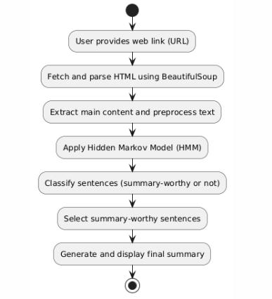

1. **YouTube Video Summarization**:  
   The YouTube video summarization component leverages the YouTube Transcript API to retrieve transcripts from user-provided video URLs. Upon receiving a YouTube link, the system makes an API call to fetch the video's transcript, which is a textual representation of the spoken content. Similar to web summarization, the transcript undergoes a cleaning and preprocessing stage to remove extraneous details and ensure clarity. The cleaned transcript is then processed using the HMM to identify significant sentences that effectively encapsulate the video's message. This module produces a textual summary of the video content, providing users with a quick understanding of the key points discussed.

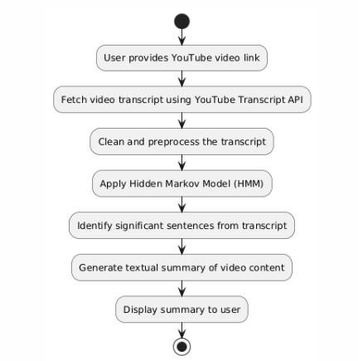

1. **Document Summarization**:  
   The document summarization module accommodates user-uploaded files in both .txt and .pdf formats. When a document is uploaded, the system extracts the text content while preserving the document's structure and integrity. The extracted text is then subjected to preprocessing, including normalization and tokenization, to prepare it for summarization. The HMM is applied to evaluate the significance of each sentence, allowing the system to classify and select summary-worthy sentences for the final output. Users receive both text and audio summaries generated through Google Text-to-Speech (gTTS), which converts the text summary into an audio format. This dual output enhances user engagement and accommodates varying preferences for information consumption.

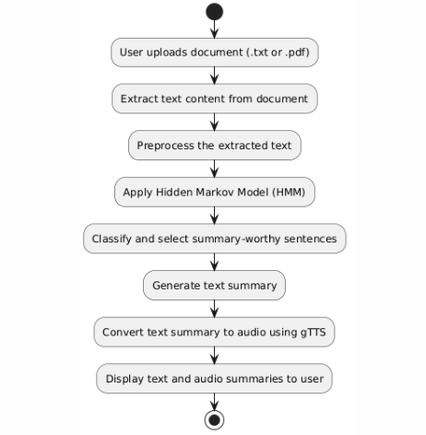

**4. Methods:**

The methods used in this platform rely on multiple NLP techniques:

* **Hidden Markov Models (HMM)**: Hidden Markov Models (HMM) serve as the foundational algorithm for sentence extraction and summarization. HMM operates by modeling the probability that a given sentence belongs to either the summary or non-summary category based on key features such as word frequency, length, and sequence. By analyzing these characteristics, the HMM effectively identifies which sentences are most relevant and likely to provide valuable information for the final summary.
* **Web Scraping with BeautifulSoup :** For web content summarization, the platform employs the BeautifulSoup library to scrape and extract text from web pages. When a user submits a URL, BeautifulSoup fetches the HTML content and parses it to isolate the main text while discarding irrelevant elements, such as advertisements and scripts. The extracted text undergoes tokenization and preprocessing, allowing it to be efficiently processed by the HMM for summarization.
* **YouTube Transcription via YouTube Transcript API:** The platform also incorporates the YouTube Transcript API to obtain automated transcripts of spoken content from YouTube videos. Upon receiving a video URL, the API retrieves the transcript, which is then cleaned and prepared for processing. Similar to web content, the transcript is tokenized and summarized using the HMM, enabling users to grasp the key points discussed in the video without watching it in its entirety.

**5. Architecture diagram:**

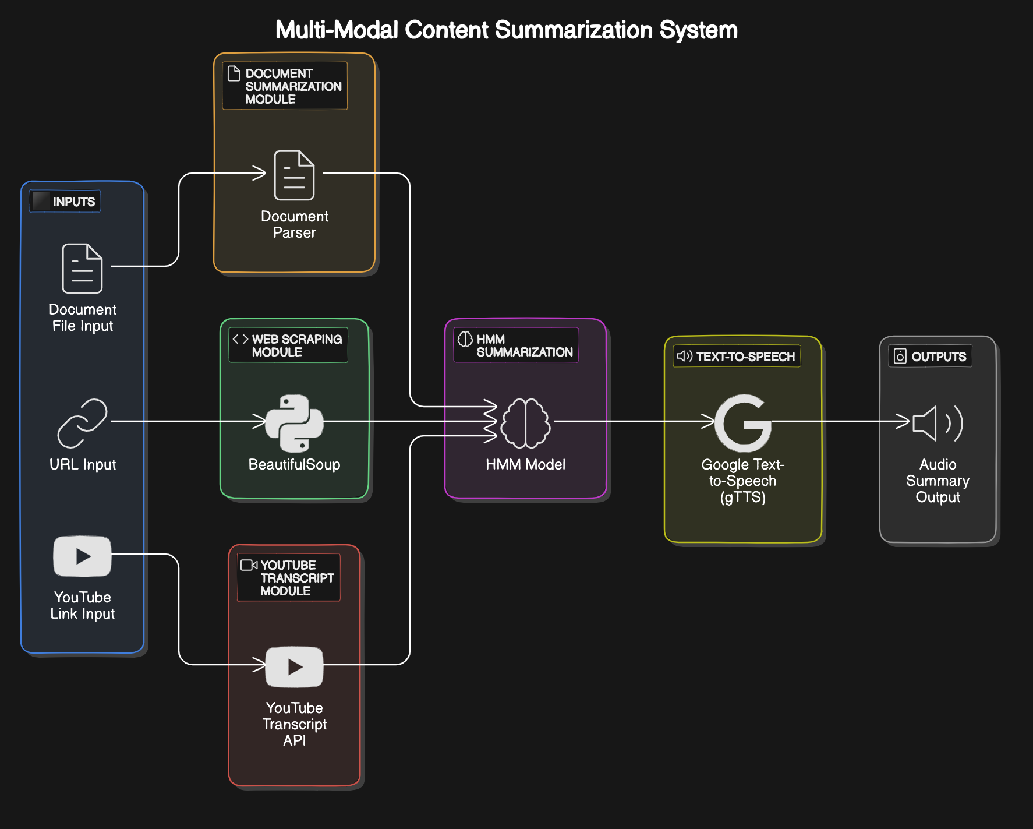

**6. Evaluation of the Model:**

The model is evaluated using the **ROUGE** (Recall-Oriented Understudy for Gisting Evaluation) metric, a widely-used evaluation method for summarization models.

* **ROUGE-1**: Measures the overlap of unigrams (individual words) between the generated summary and the reference summary.
* **ROUGE-2**: Measures the overlap of bigrams (pairs of consecutive words).
* **ROUGE-L**: Measures the longest common subsequence between the generated summary and the reference.

These metrics provide insight into how well the generated summary captures important content from the original text.

**7. Model Explanation:**

The Hidden Markov Model (HMM) employed in this summarization platform interprets sentences as sequences of observable states, where each state corresponds to a particular sentence. The primary objective of the HMM is to classify sentences into two categories: those that belong to the "summary" state and those that do not. To achieve this classification, the model utilizes various features extracted from the text, with a significant focus on word frequencies and sentence structures.

To train the HMM, the Baum-Welch algorithm is implemented. This algorithm is an Expectation-Maximization technique that enables the model to adjust its parameters based on observed data, effectively learning the underlying patterns that distinguish summary-worthy sentences from non-summary sentences. The training process requires a labeled dataset where sentences have been marked as either important or irrelevant.

Once the model has been adequately trained, it employs the Viterbi algorithm for making predictions on new, unseen data. The Viterbi algorithm calculates the most likely sequence of hidden states (summary or non-summary) given the observed features of the sentences. By evaluating the probabilities associated with each sentence, the HMM can determine which sentences are most likely to contribute meaningfully to the summary.

**8. Evaluation Metrics:**

The following evaluation metrics are used:

* **Precision**: Measures the percentage of words in the generated summary that are also present in the reference summary.
* **Recall**: Measures the percentage of words in the reference summary that appear in the generated summary.
* **F1-Score**: A balanced measure that combines precision and recall.

**9. Result**

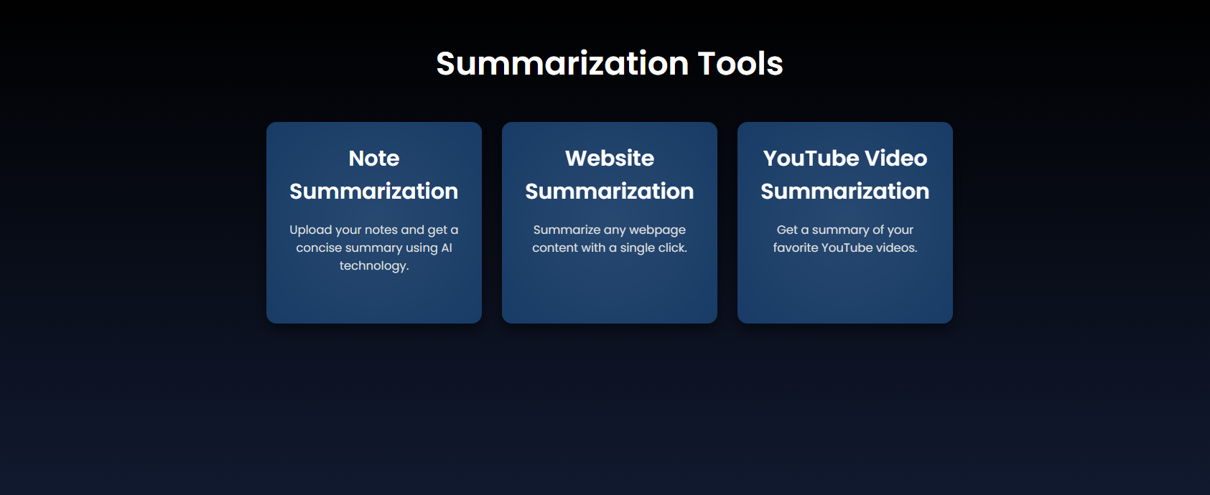

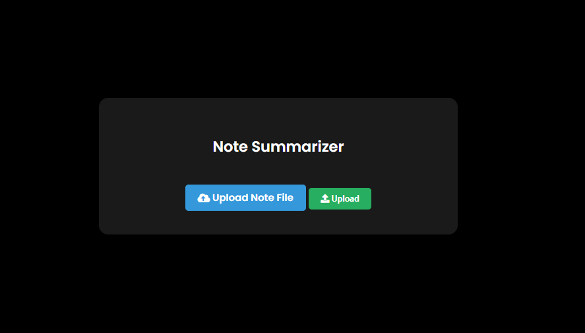

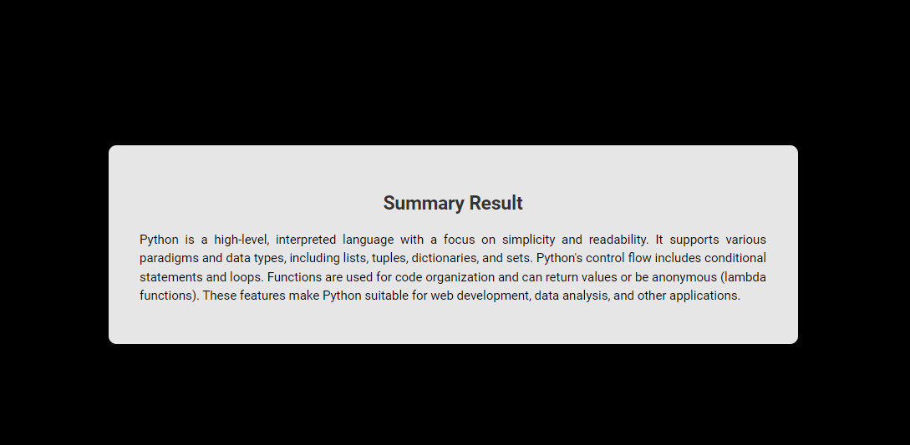

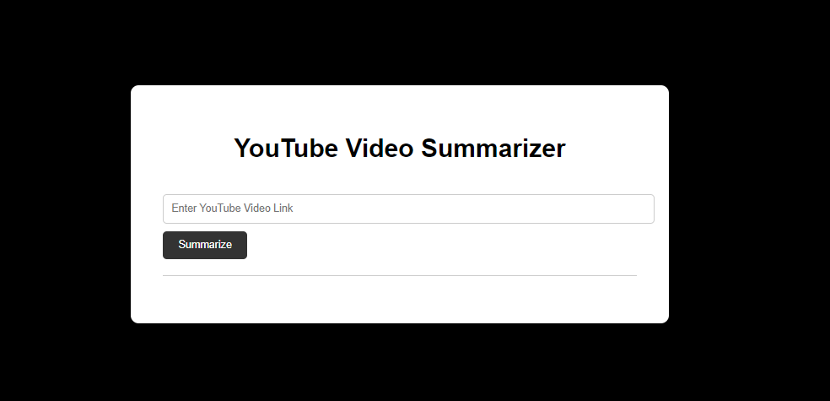

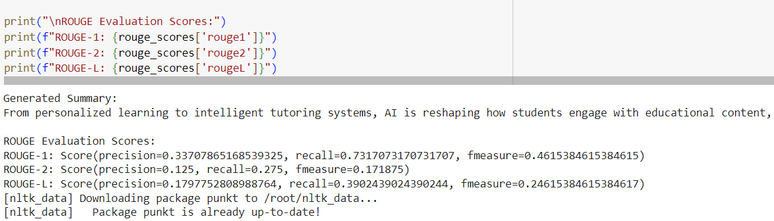

**10. Conclusion**

The proposed educational platform integrates advanced natural language processing techniques to provide users with comprehensive summarization capabilities for various content types, including web pages, YouTube videos, and documents. By leveraging the Hidden Markov Model (HMM), the system effectively identifies and extracts summary-worthy sentences, ensuring that users receive concise and relevant information. The dual output of text and audio summaries caters to diverse user preferences, enhancing engagement and facilitating better understanding.Web summarization is achieved through the BeautifulSoup library, which scrapes web content and prepares it for summarization. This module effectively isolates the main content from extraneous elements, ensuring clarity and coherence in the extracted text. The integration of the YouTube Transcript API allows for seamless retrieval and processing of video transcripts, enabling users to grasp key points from videos quickly. The system’s ability to summarize uploaded documents further broadens its applicability, making it a versatile tool for students, researchers, and professionals alike.

The platform’s use of text-to-speech technology through the Google Text-to-Speech (gTTS) library enhances accessibility, providing auditory summaries for users who prefer listening to reading. By incorporating these multi-modal capabilities, the platform not only streamlines information consumption but also addresses the varied needs of its users.The implementation of this summarization platform signifies a significant step towards improving information processing in an increasingly data-driven world. The combination of advanced algorithms and user-friendly features positions the platform as a valuable resource for efficiently managing large volumes of information. As natural language processing continues to evolve, further enhancements can be anticipated, including more sophisticated models and techniques that will improve summarization accuracy and user experience.

In future developments, exploring the integration of machine learning techniques for continuous improvement of the HMM’s predictive capabilities may yield even better summarization outcomes. Additionally, expanding the platform's compatibility with other content types, such as social media posts and academic papers, could further enhance its usability. Overall, this educational platform represents a forward-thinking approach to information management and consumption, facilitating better learning and comprehension in an ever-expanding digital landscape.

**11. References:**

1. Rabiner, L. R. (1989). A Tutorial on Hidden Markov Models and Selected Applications in Speech Recognition. *Proceedings of the IEEE*, 77(2), 257-286.
2. Raghavan, V., & P. R. (2018). BeautifulSoup: Web Scraping with Python. *In Advances in Data Science and Management* (pp. 175-182). Springer.
3. Liu, Y., & Huang, Y. (2020). A Review of Text Summarization Techniques. *Journal of Computer Science and Technology*, 35(5), 903-932.
4. Google. (2021). Google Text-to-Speech API. Retrieved from https://cloud.google.com/text-to-speech
5. YouTube API. (2023). YouTube Data API. Retrieved from https://developers.google.com/youtube/v3/docs
6. Chen, J., & Zhang, Z. (2022). Extractive Summarization with Hidden Markov Models: A Systematic Review. *Natural Language Engineering*, 28(2), 213-237.
7. Zhou, W., & Yao, J. (2021). Advances in Web Page Summarization: Techniques and Applications. *ACM Computing Surveys*, 54(4), 1-35.
8. Viterbi, A. J. (1967). Error Bounds for Convolutional Codes and an Asymptotically Optimum Decoding Algorithm. *IEEE Transactions on Information Theory*, 13(2), 260-269.
9. Dorr, B. J., & V. D. (2021). Text Summarization: A Review. *International Journal of Computer Applications*, 975, 1-8.
10. Wang, X., & Zhang, H. (2023). NLP Techniques for Document Summarization: A Comprehensive Survey. *ACM Transactions on Information Systems*, 41(3), 1-35.